Group 4
Nguyễn Ngọc Thảo An – 103240210
Lê Hồ Thu Giang – 106240409
Nguyễn Đặng Quốc Đạt – 106240045

KAPPA FOUNDATION
Initial Decision Record | Case decision: 31 December 2022

Proposed policy. Reserve sufficient default-free case-bond principal for the two fixed liabilities; invest the remaining initial capital in a constrained growth portfolio. The 2030 real-value objective is a target, not a guaranteed outcome. We select Sample Mean-Variance (MV) for growth, conditional on the stated assumptions and risk review rules.
- Candidate universe
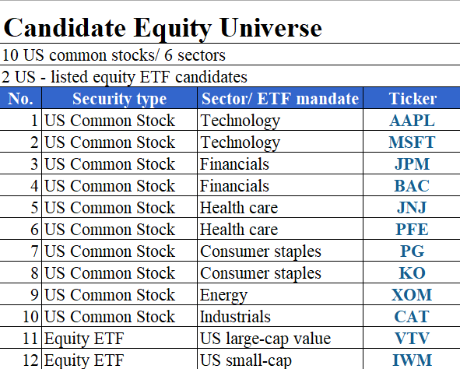
These offer distinct mandates; a zero portfolio weight is permitted. Eligibility as at the case date must be documented in the dated data record.

- Estimation window
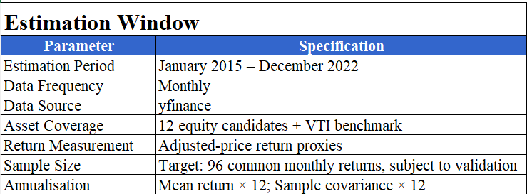
Data treatment: December 2014 adjusted prices are required to calculate January 2015 returns. Only observations available through the 31 December 2022 information cutoff are used for portfolio estimation and selection. January 2023 - December 2025 is reserved for out-of-sample evaluation.

- Benchmark
We select the Vanguard Total Stock Market ETF (VTI) as a diversified, investable benchmark for the growth portfolio. VTI represents the broad US equity market and provides a simple alternative against which to evaluate our investment strategy. For a fair comparison, both portfolios use the same entry date, transaction costs, dividend treatment, and evaluation period. The bond allocation is assessed separately based on contractual cash flows and interest-rate scenarios.
- Initial dollar allocation (USD 12 million)
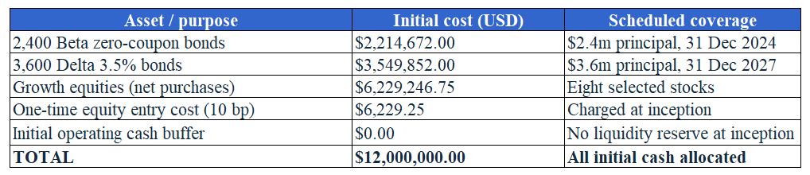
Growth purchases (share of growth / USD): Eight positive holdings; BAC, XOM, VTV and IWM receive zero weight.
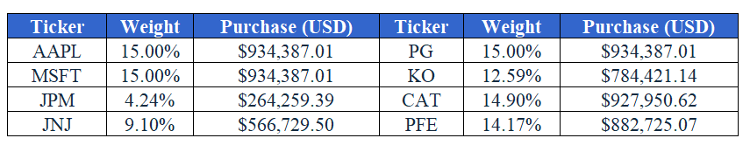
Funding cash flows: Beta pays $2.4m in 2024. Delta pays $126,000 coupons each year 2023-2027 and $3.6m principal in 2027. Base policy holds the $630,000 accumulated coupons in cash at 0% through 2030; coupons are neither added to initial growth capital nor counted twice against the liabilities.

- Material assumptions and decision evidence
Investment constraints. We follow the case restrictions on borrowing, short selling and derivatives. Each direct stock is limited to 15% of the growth portfolio, with a 30% limit per direct-stock sector to control concentration risk.
Return and risk assumptions. Expected annual returns combine 25% of each asset's historical mean and 75% of VTI's historical mean, annualised by multiplying by 12. This reduces reliance on individual stock estimates. We use A = 3 for the base utility comparison and A = 6 for sensitivity analysis. The utility measure covers the equity sleeve, not the entire fund.
Inflation and funding. We assume 2.3% annual inflation, using the 30 December 2022 US 10-year breakeven rate as a planning reference rather than a forecast. The initial cash buffer is $0, while Delta's coupons are retained at 0% interest. We also test a $250,000 buffer. Equity entry costs are set at 10 bps, including for VTI, with dividends reflected in adjusted-price return proxies rather than counted twice.
Bond valuation. We derive the first three spot rates from Alpha, Beta and Gamma. Since the fourth-year rate is unavailable, we assume s4 = s3 and infer the fifth-year rate from Delta. We test ±100 bps parallel rate shifts and changes in curve shape to assess valuation risk.
Our decision. Under the base assumptions, Sample Mean-Variance provides the highest estimated equity utility among the tested portfolios. Minimum-Variance remains a lower-risk alternative. The preference between these two fixed portfolios reverses at approximately A = 8.91. We therefore recommend Sample MV under our stated assumptions, while recognising that the result is sensitive to risk preferences and return estimates.
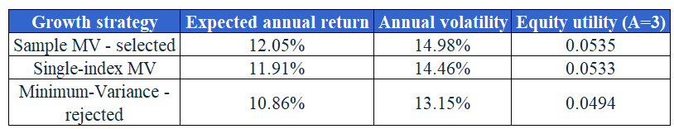
Risks and trade-offs. A -30% equity shock plus a +100 bp yield shift for Beta and Delta produces an estimated initial whole-fund mark-to-market decline of about 17.22% using exact bond repricing in the workbook. This breaches the trustees' area of concern near 15%; it is not a return forecast or acceptable-loss guarantee. Matched maturities still meet the two contractual payments if held to maturity under the case's default-free assumption. At 2.3% inflation, the 2030 real-value goal implies roughly $9.596m nominal; with coupons held at 0%, growth equities require about 4.66% annual geometric growth, not a promised return.
- Evaluation and rebalancing rule (frozen policy)
Implementation: Establish the fixed dollar allocations above. For evaluation, use fractional equity purchases at the 3 January 2023 closing-price proxy after 10 bp entry costs, and apply the same rule to VTI. This execution convention is specified before viewing the subsequent performance period.
Rebalancing: No discretionary trading and no resetting equity weights to targets during 2023-2025. Allow weights to drift; model cash dividends reinvested in the same security via adjusted-close total-return proxies. Handle mandatory corporate actions consistently, with no voluntary tender or exchange elections.
Monitoring: Report the growth sleeve's compound return, volatility, maximum drawdown and active return relative to frozen VTI over 2023-2025. Evaluate bonds through contractual cash flows, duration/convexity and explicit yield scenarios rather than fictitious observed bond prices. Record liabilities as withdrawals, not investment losses.
Review triggers: A modelled, withdrawal-adjusted trailing 12-month whole-fund loss of 12% prompts an early warning; at 15% the investment committee must review the policy within 10 business days. A review does not itself authorise retrospective rebalancing. Any post-22 October change, including the trustees' revised mandate, must be logged against this original policy with its date and evidence.

